Security Lending Workflow (SLW)

Brief description
Application to manage client request to OPT- out or OPT-in the securities in the Bank.
The commercial Team (requestors) generates the request, the client signs the documents through DocuSign or manually sent by the commercial Team. The documents then are revied by Client Back office (Approvers) and then the decision is sent to T24 to update the client´s OPT

Actors
Actor | Description
Requestor Team | Members of this group can create and edit cases
Supervisor Team | Members of this group can view and edit all cases
Approver Team | Members of this group approve of all cases
Notification Team | Members of this group receive a notification email when the client´s security lending opt is updated in T24
Audit | Members of this group can view all cases

Concepts
Table | Description
"SLW_REQUEST" | Main table where is stored all OPT-IN and OPT-OUT requests
"SLW_SIGNERS" | Stores the client signers for the OPT-IN and OPT-OUT forms
"SLW_STATUS_LOG" | Audit trail, where is stored the request status progression
"SLW_ERRORS" | Stores al web api service errors, this table allows the user to control and retry the web api services
"SLW_SIGNER_PHONES" | Stores the client´s party phone numbers

View | Description
"V_SLW_REQUEST_CLIENT" | Shows the request, client and commercial information

Case cod status | Case description status | Case status description
1 | Signing Process | The Documents were sent to the client to be signed manually or via DocuSign
2 | Pending Review | The Client Back-office team need to review the case and approve or reject it
3 | Rejected | Request rejected by the Client Back-office team
4 | Changes Required | Status assigned by the Client Back-office team to the requestor. The user is required to modify the request
5 | Approved | Client Back office approved the request and the workflow was completed successfully
6 | Action Required | There is an issue with a web api, the requestor or the client back-office team must retry the service manually
7 | In Process | Transitory status between tasks to let the user know the request is processing data in T24 or 360

Center logics
This application is developed with multicenter logic but will be used only for Miami center.
There is no user or integration configured for Geneva or Bahamas

Workflow
Below is the Appian workflow, where is shown the tasks that need to be completed to change the client´s OPT in T24
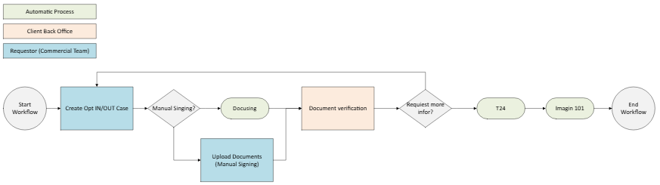
In summary, the commercial Team as Requestor enters in Appian and creates the case and sends the documents to the client via DocuSign or manual signing. In case the documents were sent manually, the requestor has another task to upload the documents in the Appian case. Afterwards the Client Back-office team approve/reject the case or request more information. If the Client Back-office approves, then the client is updated in T24 otherwise the case is rejected and the requestor is informed. The signed document is sent to Imagine101 and the client´s list of documents (Globus) is updated.

Create Case
Security and Access
- Requestor Team
Use Case
- On the home page, at the top left of the screen the user clicks the button “Create Request”
- The user can filter the clients by name or Id
- Once the user inserts the client’s name or id, the application shows the following client information
  - Client Information
    - Full Client Name
    - Client Id
    - Banker Name
    - Current client´s OPT
  - Request information
    - Request type
      - If the current OPT is opt-in, in this field will show opt-out
      - If the current OPT is opt-out, in this field will show opt-in
    - Parties
      - Full name
      - Power Type
      - Signing Type
      - Join Type
      - Email
      - Address
- The user is required to select the parties to sign the documents, and can modify the party´s email or phone number
- The user is required to select if the signing process is through DocuSign or manual signing
  - If the user selects Manual signing the user is required to download the documents generated in Appian
    - The user has an optional comment field and an optional upload field
  - If the user selects Automatic (DocuSign) the application prompts the activity record fields:
    - Place,
    - Type
    - Activity Date
    - Description
- The user is required to click on submit
Actions
- Submit
  - Signing Type: Manual
    - The application updates the case status to “Signing Process”
    - The application generates a task for the requestor to upload the documents signed by the client
    - The application sends an email to the requestor to let them know there is a task pending on Security Lending workflow
  - Signing Type: Automatic (DocuSign)
    - The application sends the documents generated in Appian to the client´s email and phone number defined in the request
    - The client signs the documents through DocuSign and the document returns to Appian by an automatic process
    - Once the documents signed returns to Appian the application generates the task “Document Verification” for the Approver Team
    - The application sends a notification email to the approver team to let them know there is a new task to review in Appian
- Cancel
  - The application returns to the home page and no data is stored

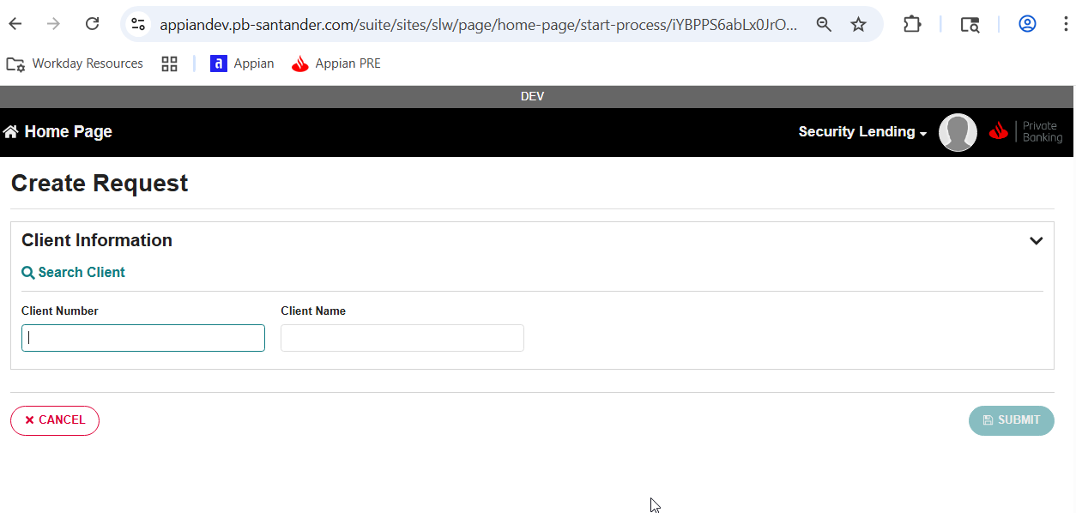
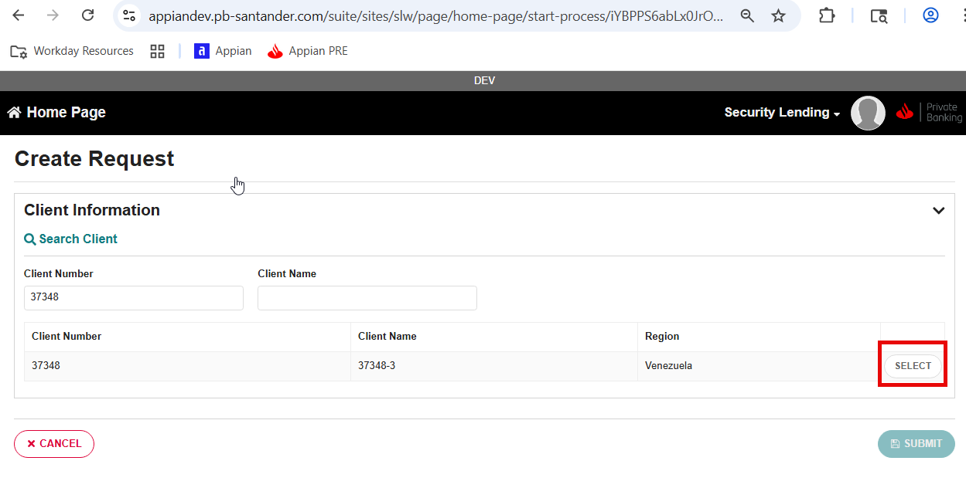
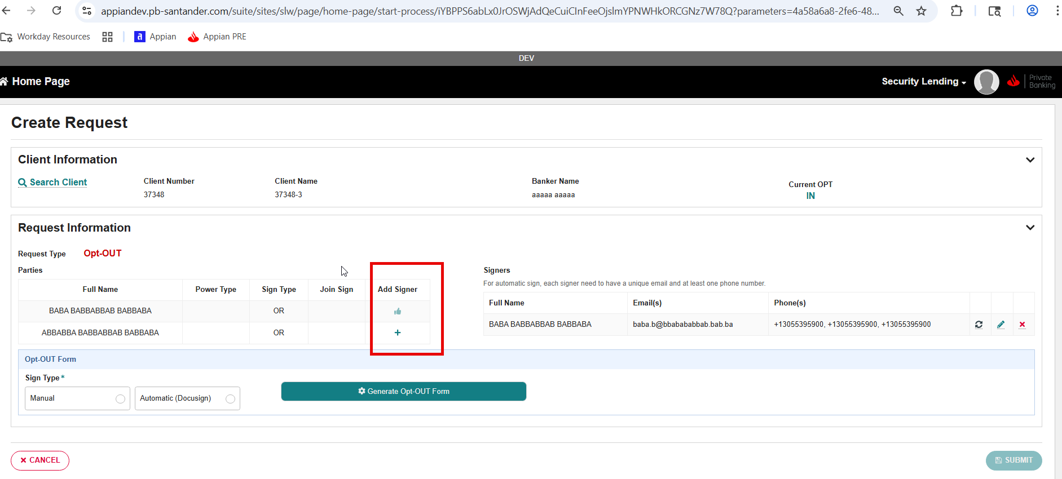

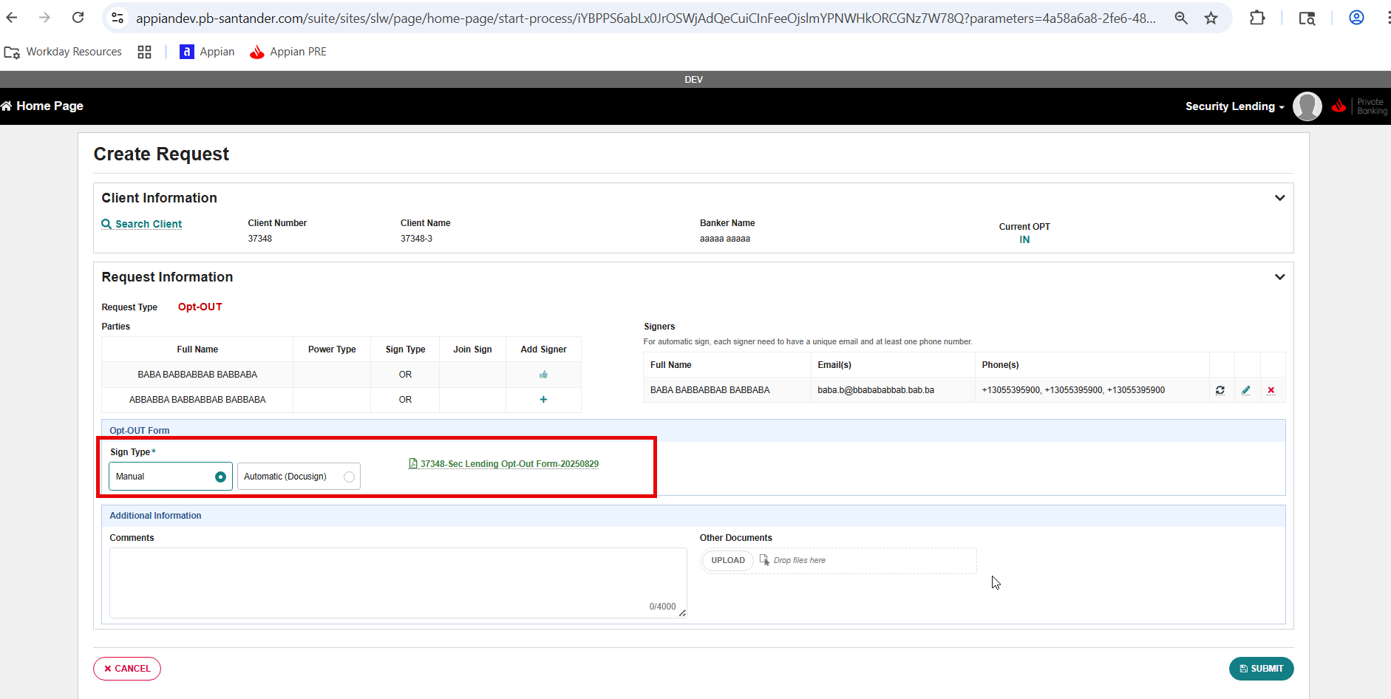

Upload Documents
Security and Access
- Requestor Team
Use case
- On the home page, the user can access the request from the “All Requests” tab or from “My Tasks” tab, by clicking the case ID from the Home page grid
- The application will show all data filled in and the documents generated by Appian
- The user is required to click at the top right of the screen, the button “Upload Signed OPT Form”
- The user is required to fill in the following data:
  - Activity Report
    - Place
    - Type
    - Description
    - Activity Date
  - Signed documents
    - Upload documents
    - Signing date
  - Once the information is filled out, the user is required to click on submit or cancel
Actions
- Submit
  - The application updates the case status to “Pending Review” and generates the task “Document Verification”
  - The application sends a notification email to the Approver team to let them know there is a new task that requires their attention
- Cancel
  - The application returns to the case and no data is stored

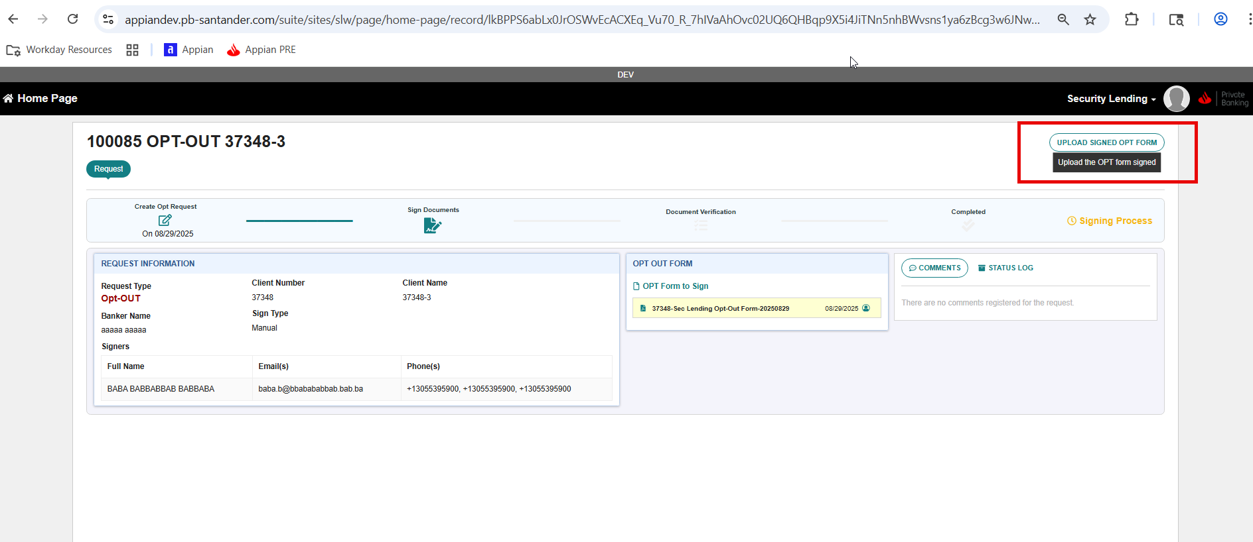

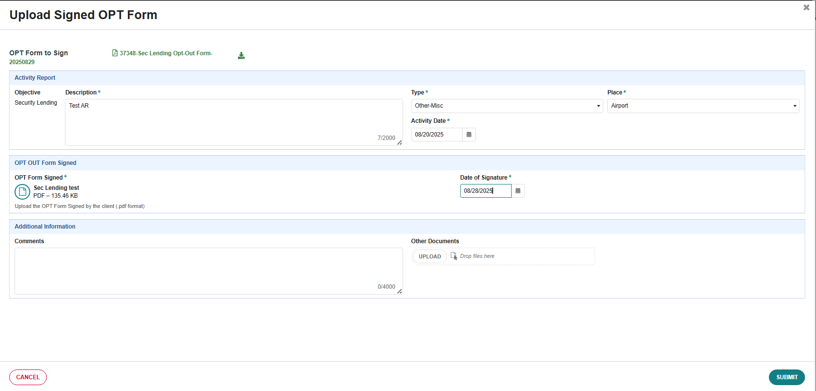

DocuSign - Automatic process
Appian process that is executed after the creation of the case, when the user selects the Automatic (DocuSign) button.
- The process sends the OPT-Form document generated in Appian to the client through the DocuSign process.
- The DocuSign process sends an email to each party selected as signers where the client is required to open and sign the documents
- The Docusign process used the party phone number as a double verification step using the SMS
- Once the client verifies the identity with the phone SMS received is required to open the document and sign it.
- Every 15 minutes Appian verifies the document state and in case the document is signed they are uploaded inside the client case in Security Lending Workflow
- And lastly once the documents signed are located inside the client case the application generates a task to Client Back-office to approve the documents.
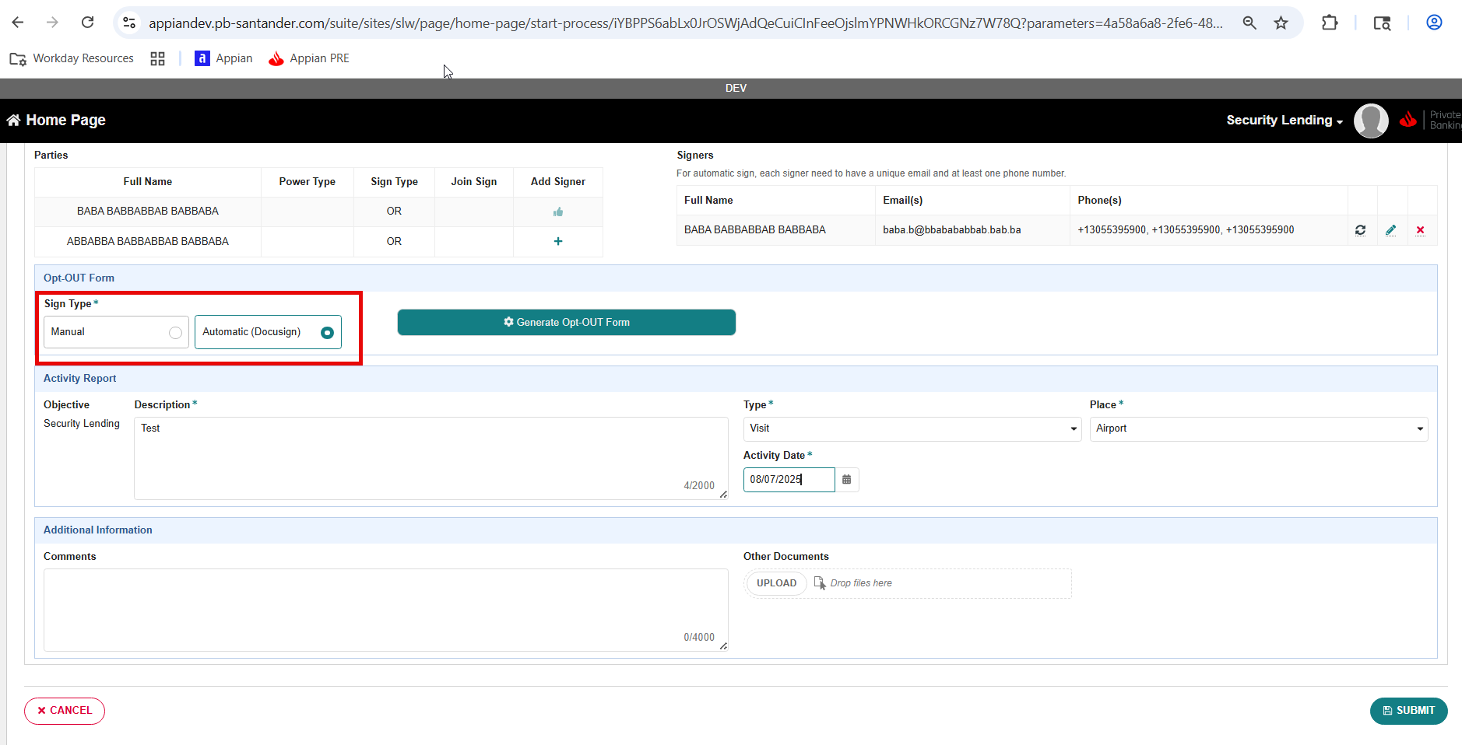

Document Verification
Security and Access
- Client Back-office
Use Case
- On the home page, the user can access the request from the “All Requests” tab or from “My Tasks” tab, by clicking the case ID from the Home page grid
- The application will show all data filled in and the client´s documents
- The user is required to click at the top right of the screen, the button “Review Request”
- The application will prompt a screen with the signed documents and the user is required to select one of the options: approve / reject / request more information
  - In case the user wants to reject or request more information, it is required also to add a comment
Actions
- Approve:
  - The application will update the case status to Approved and store the optional documents and comments
  - The application will send the information to T24 to update the client´s OPT
  - The application will send the client´s documents to Imaging101
  - The application will notify the Treasure team that the client was updated in T24
- Reject:
  - The application will update the case status to Rejected and store the optional documents and comments
  - The application will notify the requestor that the case was rejected
- Request more information
  - The application will update the case status to Changes Required and store the optional documents and comments
  - The application generates a new task to the requestor and sends a notification email to the requestor to inform them there is a case that needs to be reviewed.
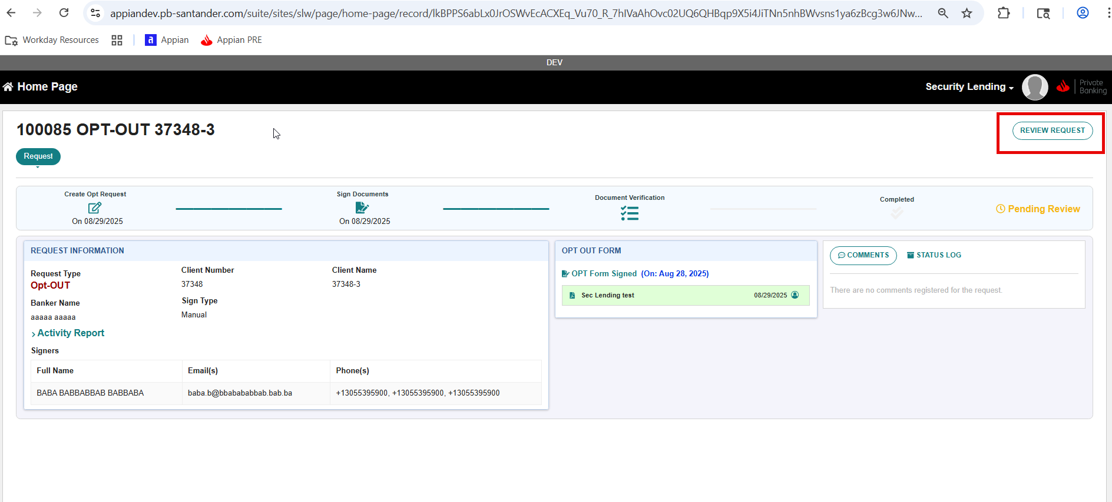
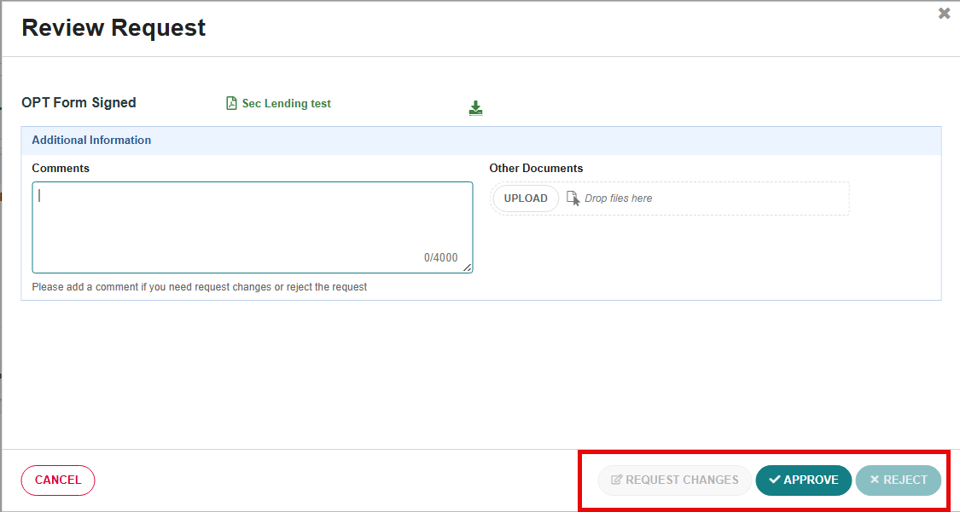

T24 / Imaging101 - Update Client
An automatic process that executes once the Client Back Office (approver team) approve the case.
- The application sends the client´s OPT-IN or OPT-OUT changes to T24 and controls the web api update status.
- In case the update is successful, the application sends the case documents to Imaging101 client folder.
- Once the documents are stored in Imaging101 the application sends a notification email to Treasury team to inform them the workflow was completed, and the client was updated.
- Finally, the client’s list of documents is updated with the new signed document (OPT IN/OUT form).
- On the other hand, if there is an issue with T24 or Imaging101 services the application generates a task to the users to retry the services.
- If the issues persist the user is required to reach the IT Team to review the problem.

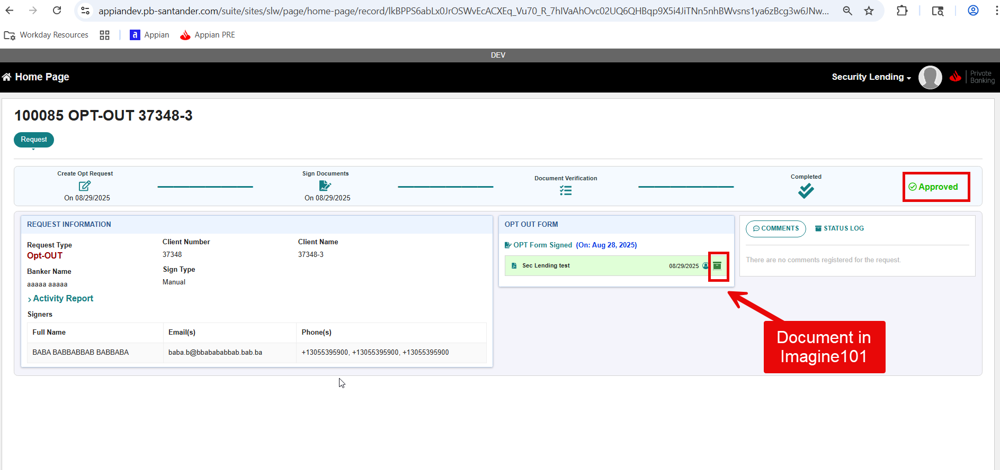

Integrations
T24:
- Get Customer Relations:
  - Appian object: BPI_T24_INT_GetCustomerRelations_MIA
  - url: https://apigwtest.mia.usa.sinvest/digitalwealth/develop/creditproposal/v1/ClientRelations
- Update Client OPT in T24:
  - Appian Object: SLW_INT_T24_UpdateCustomer_MIA
  - url: https://apigwtest.mia.usa.sinvest/digitalwealth/develop/customer/v3/customers
- Send Documents to Imaging101:
  - Appian object: BPI_T24_INT_WriteDocumentImaging101_MIA
  - url: https://apigwtest.mia.usa.sinvest/digitalwealth/develop/document/v1/saveDocument

- Update client´s document list in Globus:
  - To get entity/client documents:
    - Appian object: BPI_T24_INT_GetEntityDocs_MIA
    - url:
https://apigwtest.mia.usa.sinvest/digitalwealth/develop/appway/v2/ entityDoc/[“C”+ClientNumber]
  - To update entity/client documents:
    - Appian object: BPI_T24_INT_WriteEntityDocs_MIA
    - url:
https://apigwtest.mia.usa.sinvest/digitalwealth/develop/appway/v2/entityDoc

DocuSign
- Send document to DocuSign
  - Appian object: BPI_DCSGN_PM_CreateSendEnvelope
- Cancel DocuSign process
  - Appian object: BPI_DCSGN_PM_VoidEnvelope
- Update document envelope
  - Appian object: BPI_DCSGN_PM_BatchByInstallation

Integration usage:
- The Commercial Team Enters in Appian and search the client in Medea
- Once retrieved the client Id, the application searches the client´s parties using the service Get Customer Relations “https://apigwtest.mia.usa.sinvest/digitalwealth/develop/creditproposal/v1/ClientRelations”
- If the user sends the documents through DocuSign, the application sends the document, party´s phone number and email using the process model BPI_DCSGN_PM_CreateSendEnvelope.
- The application has a process model (SLW_GetDocuSignEventsStatus) that updates the document status in DocuSign which is executed by the batch process: BPI_DCSGN_PM_BatchByInstallation.
- Once stored the documents signed the Client Backoffice team approve the case and the client´s OPT decision is sent to T24 using the service Update Client´s OPT in T24 https://apigwtest.mia.usa.sinvest/digitalwealth/develop/customer/v3/customers
- Afterwards the Appian process sends the client´s document to Imaign101 using the service Send Document to Imaging101 https://apigwtest.mia.usa.sinvest/digitalwealth/develop/document/v1/saveDocument and the workflow ends
- Finally the application updates the Globus entity documents by executing the service https://apigwtest.mia.usa.sinvest/digitalwealth/develop/appway/v2/entityDoc GET and then POST.

Error Handling
In case an error occurs calling an integration, the process saves the error in the database and changes the request status to Action Required. The user (the last work in the request) can retry the integration call or take other way (only in case error in 360 or DocuSign). A retry system allows retries of the action but if the number of retries exceeds the limit, a warning is showed and the user have to send the error to Appian IT Support.
